Dr. Pramod Singh
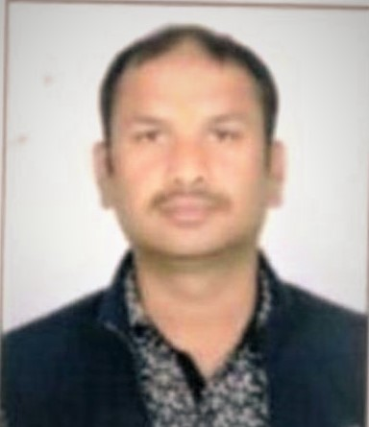
Assistant Professor
School of Studies in Computer Application
Bastar Vishwavidyalaya, Jagdalpur
Distt- Bastar, Chhattisgarh, India
E-mail: Pramodsinghbvv@gmail.com
Contact: 9691078337, 8827367559
Experience | 10 years’ teaching experience
Qualification | BCA, MCA, Ph.D
Journal Publication | 11
Conference Publication | 05
Book Publication | 02
Duties Performed Related To National Seminar/ Workshop/Training etc. | Coordinator FDP, Coordinator Training program, Organizing secretory workshop,  Committee member
Duties Related To Administration | Admission incharge, HOD Incharge ,member of different committees
Duties Related To Examination | Exam Center Superintendent, Semester Examination Invigilator Duties, Examiner Of Answer Book Evaluation And Practical Examination
Attend National Seminar/Workshop/Training etc. | 20
Deliver Invited Lectures/Workshop/Training | 05
Membership Of Learned Societies/ Professional Bodies | 01

